Employee CV · Harbourside District Infrastructure Programme, Package 3  Proposed position  Project Director / Team Leader  Daniel Okafor  Director, Infrastructure · Arcadia Engineering Partners  Client Meridian Development Authority | 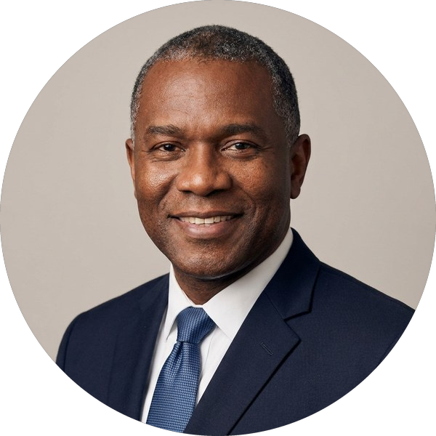

Nationality | British | Date of birth | 14 March 1975
Professional experience | 26 years | Years with the firm | 11 years (Arcadia Engineering Partners)
Years in the region | 14 years (GCC) | Languages | English (native), Arabic (working)
Key qualifications
Daniel is a chartered civil engineer with 26 years in the design and delivery of urban infrastructure, 14 of them in the GCC. He has led construction supervision teams of up to 140 staff on road, drainage and utilities programmes worth more than QAR 6bn, and has directed three district-scale infrastructure packages from design review to handover.
■ Team Leader on three district infrastructure packages for public-sector clients in the GCC
■ Supervision of roads, deep drainage, utilities diversions and public realm works
■ FIDIC 1999 and 2017 contract administration, claims and variation management
■ Leads integrated client-side teams of engineers, inspectors and HSE staff
Education
Degree / qualification | Institution | Year
MSc Construction Management | University of Reading | 2001
BEng (Hons) Civil Engineering | University of Nottingham | 1998
Professional memberships and registrations
■ Chartered Engineer (CEng), Engineering Council UK (2004)
■ Fellow, Institution of Civil Engineers (FICE)
■ Project Management Professional (PMP), Project Management Institute
■ Registered Consultant Engineer, Grade A, national engineers register (Qatar)
Employment record
From – to | Employer | Position
2015 – Present | Arcadia Engineering Partners  Doha, Qatar | Director, Infrastructure
2009 – 2015 | Calder & Whitby Consulting Engineers  Dubai, UAE | Associate Director, Roads & Drainage
2003 – 2009 | Westmark Infrastructure  Birmingham, UK | Senior Resident Engineer
1998 – 2003 | Fenmore County Council  Nottingham, UK | Graduate to Senior Engineer
Relevant project experience
2021 – 2025  Doha, Qatar  Value  QAR 2.1bn | Al Noor District Roads and Drainage, Package 2  Client Eastgate Public Works Authority  Role Team Leader / Engineer’s Representative  Led a 120-strong supervision team for 38 km of urban roads, 52 km of deep drainage and utilities diversions. Administered the FIDIC 1999 contract, agreed 64 variations and closed out the final account eight weeks ahead of programme.
2017 – 2021  Abu Dhabi, UAE  Value  AED 940m | Marina Quarter Infrastructure and Public Realm  Client Coastline Development Company  Role Project Director  Directed design review and construction supervision of roads, cooling networks and landscaped public realm for a 1.8 km waterfront district; chaired the monthly client steering committee.
2006 – 2009  United Kingdom  Value  £186m | Southern Ring Road Improvement Scheme  Client Fenmore Roads & Transport Authority  Role Senior Resident Engineer  Supervised junction upgrades, structures and drainage on a live dual carriageway under NEC3.

Employee CV · Harbourside District Infrastructure Programme, Package 3  Proposed position  Resident Engineer  Helena Vos  Senior Resident Engineer · Arcadia Engineering Partners  Client Meridian Development Authority | 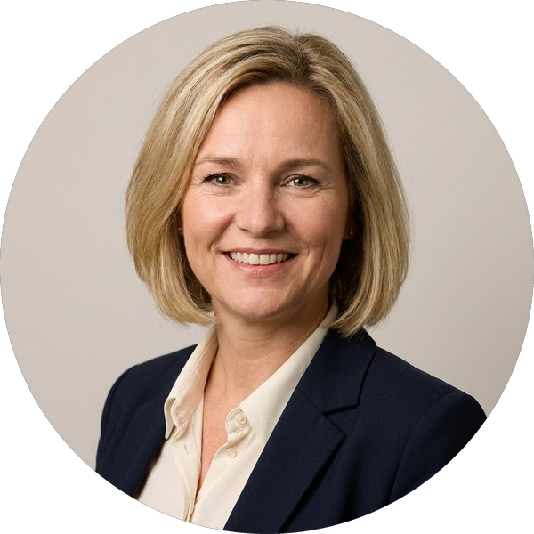

Nationality | Dutch | Date of birth | —
Professional experience | 19 years | Years with the firm | 6 years (Arcadia Engineering Partners)
Years in the region | 12 years (GCC) | Languages | English (fluent), Dutch (native), German (good)
Key qualifications
Helena is a highways engineer with 19 years in the supervision of urban road and interchange projects, including 12 years in Qatar and the UAE. She has been Resident Engineer on two expressway interchanges and leads site inspection teams through traffic diversions on live networks.
■ Resident Engineer on two major interchange and expressway contracts
■ Quality assurance of pavements, earthworks and structures under ISO 9001 plans
■ Traffic management and phased diversions on live urban networks
Education
Degree / qualification | Institution | Year
MSc Civil Engineering (Transport & Planning) | Delft University of Technology | 2006
BSc Civil Engineering | Delft University of Technology | 2004
Professional memberships and registrations
■ Registered Professional Engineer, national engineers register (Qatar)
■ Member, Royal Netherlands Society of Engineers (KIVI)
Employment record
From – to | Employer | Position
2020 – Present | Arcadia Engineering Partners  Doha, Qatar | Senior Resident Engineer
2014 – 2020 | Calder & Whitby Consulting Engineers  Abu Dhabi, UAE | Resident Engineer
2006 – 2014 | Rijnmond Infra Consult  Rotterdam, Netherlands | Highway Engineer to Senior Engineer
Relevant project experience
2020 – 2024  Doha, Qatar  Value  QAR 1.4bn | North Corridor Expressway Interchange 7  Client Eastgate Public Works Authority  Role Resident Engineer  Led site supervision of a four-level interchange, 11 bridges and 9 km of approach roads; ran the inspection and test plan and agreed traffic diversions with the police.
2016 – 2020  Abu Dhabi, UAE  Value  AED 610m | Airport Link Road Upgrade  Client Coastline Development Company  Role Resident Engineer  Supervised widening of 14 km of road to six lanes with utility relocations and night works.
2009 – 2013  Netherlands | A15 Maasvlakte Widening  Client Rijnmond Regional Roads Agency  Role Highway Engineer  Pavement and drainage design checks and site quality inspections.

Employee CV · Harbourside District Infrastructure Programme, Package 3  Proposed position  Senior Structural Engineer  Marcus Oyelaran  Principal Structural Engineer · Arcadia Engineering Partners  Client Meridian Development Authority | 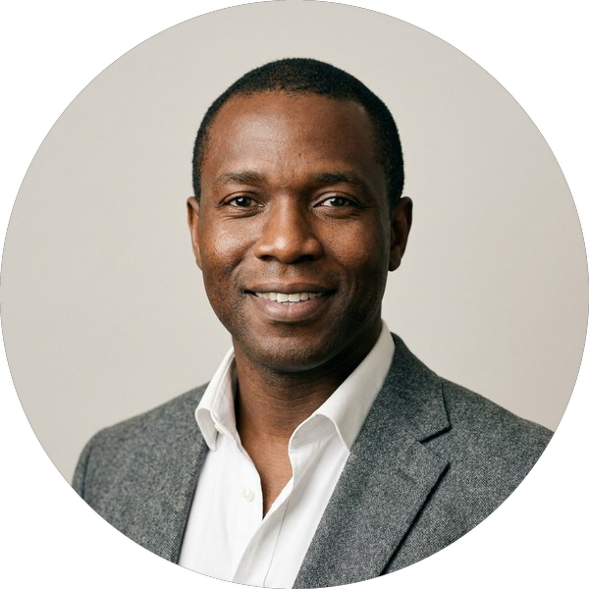

Nationality | British | Date of birth | 2 November 1983
Professional experience | 17 years | Years with the firm | 4 years (Arcadia Engineering Partners)
Years in the region | 7 years (GCC) | Languages | English (native), Yoruba (fluent)
Key qualifications
Marcus is a chartered structural engineer with 17 years in bridge, culvert and retaining-structure design and site supervision. He reviews contractor designs and temporary works and has led structural supervision on two GCC road programmes.
■ Design review of bridges, box culverts and retaining walls to BS EN and AASHTO
■ Temporary works checking and site supervision of post-tensioned decks
■ Structural inspection and load assessment of existing assets
Education
Degree / qualification | Institution | Year
MEng Structural Engineering | University of Bristol | 2007
Professional memberships and registrations
■ Chartered Structural Engineer, Institution of Structural Engineers (CEng MIStructE, 2012)
Employment record
From – to | Employer | Position
2022 – Present | Arcadia Engineering Partners  Doha, Qatar | Principal Structural Engineer
2019 – 2022 | Calder & Whitby Consulting Engineers  Dubai, UAE | Senior Bridge Engineer
2007 – 2019 | Hartwell Byrne Structures  London, UK | Graduate to Senior Engineer
Relevant project experience
2022 – 2025  Doha, Qatar  Value  QAR 2.1bn | Al Noor District Roads and Drainage, Package 2  Client Eastgate Public Works Authority  Role Structures Lead  Reviewed the contractor’s designs for 6 bridges and 23 culverts; supervised deck pours and load tests.
2019 – 2022  Dubai, UAE  Value  AED 120m | Creekside Pedestrian & Cycle Bridges  Client Coastline Development Company  Role Senior Bridge Engineer  Design checks and site supervision of three steel footbridges over an operating canal.

