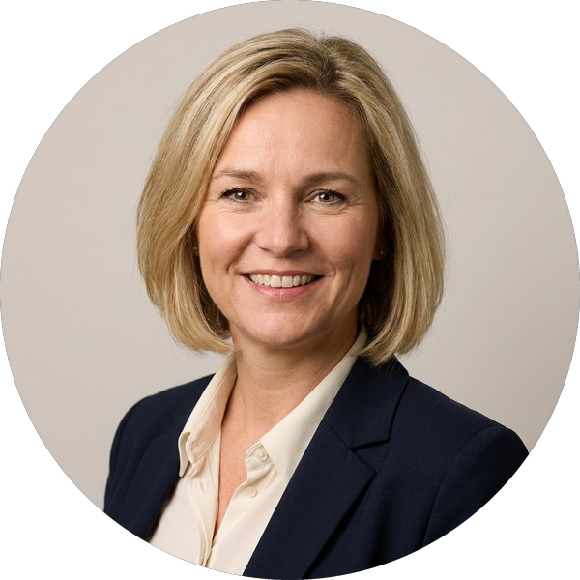 | London  Helena Vos  Partner · Ashbury & Vale LLP  Construction & Engineering · International Arbitration · Infrastructure Projects

Summary  Helena advises contractors, employers and funders on major construction and infrastructure projects and the disputes that arise from them, in the English courts and in ICC, LCIA and ad hoc arbitrations. She is known for FIDIC and NEC disputes on transport and energy projects.  Representative matters  ■ Acted for an international contractor in a US$420m ICC arbitration over delay and disruption on a metro project  ■ Advised a FTSE 100 client on the NEC4 suite for a £1.1bn water infrastructure programme  ■ Represented an employer in a TCC claim concerning defective façade works on a London tower  ■ Acted for a joint venture in an LCIA arbitration over a power-plant EPC contract  ■ Advised lenders on the construction package for an offshore wind financing  Rankings and recognition  ■ Ranked for Construction (London), leading UK legal directory, 2025 and 2026  ■ Construction Lawyer of the Year, regional legal awards (2024)  Publications and speaking  ■ “Time bars after the 2017 FIDIC suite”, construction law journal article (2024)  ■ Speaker, international construction disputes conference, Amsterdam (2025) |  | Admissions and qualifications  ■ Solicitor, England and Wales (2008)  ■ Solicitor Advocate (Higher Courts, Civil) (2014)  ■ Advocaat, Netherlands (2005)  Education  ■ LLM, International Dispute Resolution, King’s College London  ■ Meester in de Rechten, Leiden University  Languages  ■ English  ■ Dutch  ■ German  Memberships  ■ Society of Construction Law  ■ ICC Commission on Arbitration and ADR

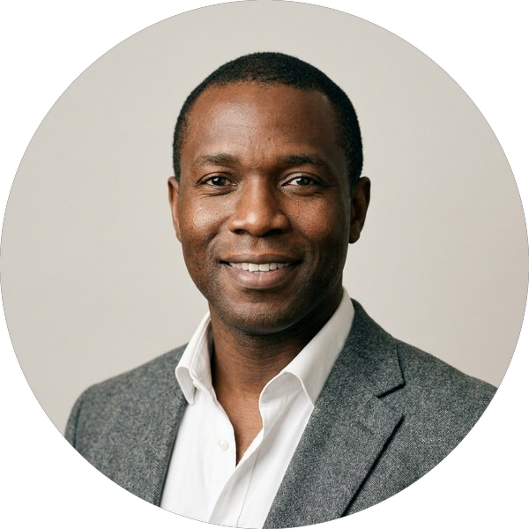 | London  Marcus Oyelaran  Counsel · Ashbury & Vale LLP  Construction & Engineering · Projects

Summary  Marcus advises on construction contracts and disputes for developers and contractors.  Representative matters  ■ Acted for a developer on adjudications under a JCT design and build contract  ■ Advised a contractor on the termination of a hospital PFI subcontract |  | Admissions and qualifications  ■ Solicitor, England and Wales (2013)  Education  ■ LLB (Hons), University of Bristol  ■ Legal Practice Course, University of Law  Languages  ■ English  ■ Yoruba  Memberships  ■ Society of Construction Law

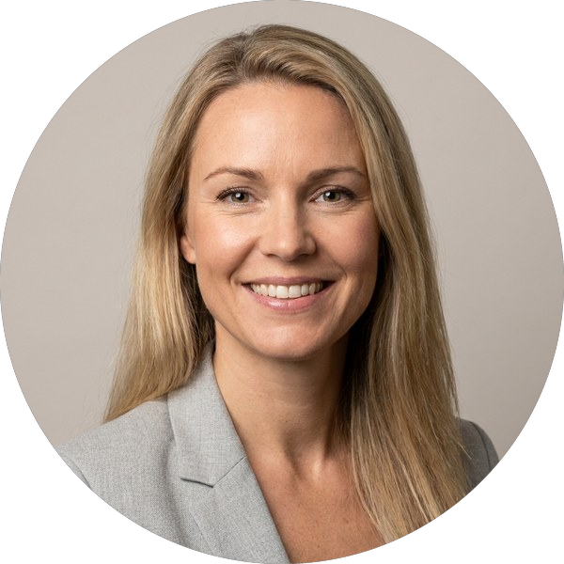 | Stockholm  Sofia Lindqvist  Senior Associate · Ashbury & Vale LLP  International Arbitration

Summary  Sofia acts in SCC and ICC arbitrations for energy and construction clients.  Representative matters  ■ Acted for a utility in an SCC arbitration over a hydropower refurbishment contract |  | Admissions and qualifications  ■ Advokat, Sweden (2016)  Education  ■ LLM, Stockholm University  Languages  ■ Swedish  ■ English  ■ French

