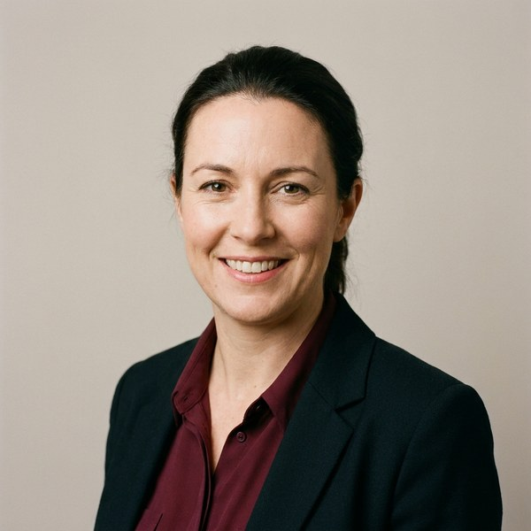 | London, UK  Eleanor Marsh FCA  Chief Financial Officer · Calder & Finch Group plc  Group finance · Mergers & Acquisitions · Capital markets · Transformation · Investor relations

Biography  Eleanor Marsh is Chief Financial Officer of Calder & Finch Group plc, the £1.9bn building-products group listed on the London Stock Exchange. Since joining in 2020, Eleanor has led the group’s refinancing, a £240m disposal programme and the move to a single finance operating model across eleven countries.  Eleanor began her career at Hartwell Thorne, qualifying as a chartered accountant before moving into industry with Brightwell & Co, where she became Group Financial Controller. She was later Finance Director of the Northern Europe division of Stratton Industrial, responsible for a £620m business and a finance team of 140, and led its carve-out from the wider group.  Eleanor is a non-executive director and chair of the audit committee at Penhallow Housing Trust and a trustee of the Fenmore Arts Foundation. She holds a BSc in Mathematics & Economics from the University of Bristol and is a Fellow of the ICAEW.  Career highlights  ■ Led a £240m disposal programme that cut net debt from 2.4x to 1.1x EBITDA within two years  ■ Moved finance in eleven countries onto one operating model, reducing finance cost by 18%  ■ Completed the £310m carve-out of Stratton Industrial’s Northern Europe division in nine months |  | Current roles  Chief Financial Officer  Calder & Finch Group plc · 2020 – present  Board and non-executive roles  Non-executive Director, Audit Chair  Penhallow Housing Trust · 2022 – present  Trustee  Fenmore Arts Foundation · 2019 – present  Previous roles  Finance Director, Northern Europe  Stratton Industrial · 2015 – 2020  Group Financial Controller  Brightwell & Co · 2010 – 2015  Audit Manager  Hartwell Thorne · 2004 – 2010  Education  ■ BSc Mathematics & Economics, University of Bristol  ■ Fellow, ICAEW (FCA)  Languages  ■ English  ■ French
  Short bio for programmes, announcements and profiles
  Eleanor Marsh is Chief Financial Officer of Calder & Finch Group plc, the £1.9bn listed building-products group, where she has led its refinancing and a £240m disposal programme. She was previously a divisional Finance Director at Stratton Industrial and chairs the audit committee of Penhallow Housing Trust.

 | Aberdeen, UK  Marcus Oyelaran CEng  Chief Operating Officer · Tolland Marine & Energy  Operations · Offshore energy · Safety leadership · Supply chain

Biography  Marcus Oyelaran is Chief Operating Officer of Tolland Marine & Energy, which runs a fleet of 42 offshore support vessels across the North Sea and West Africa. Marcus is responsible for 2,300 people, vessel operations and the group’s safety performance.  Marcus trained as a marine engineer and spent twelve years at Corran Offshore in engineering and operations roles in Aberdeen and Lagos, finishing as Operations Director for West Africa. He joined Tolland in 2018 as Fleet Director and was appointed Chief Operating Officer in 2021.  Career highlights  ■ Cut lost-time injuries by 46% across a fleet of 42 vessels between 2021 and 2025  ■ Raised fleet utilisation from 71% to 86% through a new crewing and maintenance model |  | Current roles  Chief Operating Officer  Tolland Marine & Energy · 2021 – present  Previous roles  Fleet Director  Tolland Marine & Energy · 2018 – 2021  Operations Director, West Africa  Corran Offshore · 2013 – 2018  Senior Marine Engineer  Corran Offshore · 2006 – 2013  Education  ■ MEng Marine Engineering, University of Southampton  ■ Chartered Engineer (CEng), IMarEST
  Short bio for programmes, announcements and profiles
  Marcus Oyelaran is Chief Operating Officer of Tolland Marine & Energy, responsible for 42 offshore support vessels and 2,300 people. A chartered marine engineer, he previously led operations in West Africa for Corran Offshore and has cut lost-time injuries across the fleet by 46%.

S | Stockholm, Sweden  Sofia Lindqvist  Chief People Officer · Northgate Health  Organisation design · Culture change · Reward

Biography  Sofia Lindqvist is Chief People Officer of Northgate Health, a Nordic network of 60 clinics with 4,800 employees. Sofia leads people strategy, reward and leadership development, and sits on the group executive committee.  Sofia previously held senior HR roles at Varde Retail and Ostby Telecom in Stockholm and Copenhagen. She holds an MSc in Business & Economics from the Stockholm School of Economics.  Career highlights  ■ Reduced clinical staff turnover from 21% to 13% in three years at Northgate Health |  | Current roles  Chief People Officer  Northgate Health · 2022 – present  Previous roles  HR Director, Nordics  Varde Retail · 2017 – 2022  Head of Reward  Ostby Telecom · 2012 – 2017  Education  ■ MSc Business & Economics, Stockholm School of Economics  Languages  ■ Swedish  ■ English  ■ Danish
  Short bio for programmes, announcements and profiles
  Sofia Lindqvist is Chief People Officer of Northgate Health, the Nordic network of 60 clinics, where she leads people strategy for 4,800 employees and has cut clinical staff turnover from 21% to 13%. She previously held senior HR roles at Varde Retail and Ostby Telecom.

