 | Curriculum vitae  Sofia Lindqvist  Marketing Director · Consumer brands and e-commerce  London · Notice: Three months  Presented by James Whitlock, Director, Consumer & Retail
■ Profile
Sofia is a marketing director with fifteen years in consumer brands across Sweden and the UK. She has led brand, performance and CRM teams of up to 40, relaunched two heritage brands and moved budgets towards digital channels while growing share. She is equally at home with a brand positioning workshop and a weekly trading meeting.
■ Key skills
Brand strategy ​ Performance marketing ​ CRM and loyalty ​ E‑commerce growth ​ Agency management ​ Team leadership ​ Consumer insight ​ Budgets to £18m
■ Career history
2021 – Present  London | Marketing Director  Ashby & Rowe Home  Leads brand, digital, CRM and insight, a team of 32 and an £18m budget.  – Relaunched the Ashby & Rowe brand, lifting prompted awareness from 34% to 52%  – Grew online sales from 22% to 41% of revenue in three years  – Built a loyalty programme with 1.2 million members in its first eighteen months
2016 – 2021  Stockholm | Head of Brand Marketing  Nordvik Brands  Ran brand marketing for the Nordic skincare portfolio across five markets.  – Launched the Solsken range, the group's fastest-selling launch at the time  – Moved 45% of the media budget to digital with no loss of reach
2012 – 2016  Stockholm | Senior Brand Manager  Nordvik Brands  – Managed the haircare brands, returning them to growth after three years of decline

Education  MSc Business and Economics  Stockholm School of Economics, 2010 |  | Certifications  Chartered Marketer, CIM (2019) |  | Languages  Swedish (native)  English (fluent)  German (working)
Interests Open-water swimming, Scandinavian design, and mentoring through a women in marketing network.

IQ | Curriculum vitae  Imran Qureshi  Associate Director, Structural Engineering · Commercial and rail  Birmingham · Notice: Two months  Presented by James Whitlock, Director, Built Environment
■ Profile
Imran is a chartered structural engineer with seventeen years in consultancy, leading design teams on commercial towers, stations and bridges. He has been engineer of record on schemes up to £320m, manages teams of fifteen and has a strong record with Network Rail assurance, temporary works and digital delivery in BIM.
■ Key skills
Structural design ​ Rail infrastructure ​ Steel and concrete ​ Temporary works ​ BIM Level 2 ​ Client management ​ Design team leadership ​ Bid writing ​ Value engineering ​ Mentoring graduates
■ Career history
2020 – Present  Birmingham | Associate Director, Structures  Pemberton Hale Engineering  Leads a structures team of 15 on commercial and rail schemes in the Midlands.  – Engineer of record for a 28-storey office tower, delivered £2.1m under the structural budget  – Led the station design for a £320m rail interchange through Network Rail Form 002  – Won £6.4m of new fees in three years as bid lead  – Introduced design checks in BIM that cut drawing revisions by a third
2016 – 2020  Birmingham | Principal Engineer  Pemberton Hale Engineering  Ran the design of mid-size commercial and education projects.  – Delivered the steel frame for a 40,000 m² distribution centre in 14 weeks  – Designed four school buildings under the national framework
2012 – 2016  Manchester | Senior Engineer  Carrick & Lowe Consulting  Bridge and station work for rail and highways clients.  – Designed the replacement deck for a Grade II listed rail bridge  – Led temporary works design for a live station refurbishment
2009 – 2012  Manchester | Engineer  Carrick & Lowe Consulting  – Worked on concrete frame design for residential towers  – Achieved chartership with the Institution of Structural Engineers
2007 – 2009  Leeds | Graduate Engineer  Ridley Civil Partners  – Completed the graduate scheme with placements in bridges and buildings

Education  MEng Civil and Structural Engineering  University of Sheffield, 2007 |  | Certifications  Chartered Engineer, IStructE (2012)  CSCS Professional card  Network Rail Sentinel (PTS) |  | Languages  English (native)  Urdu (fluent)  Punjabi (conversational)
Interests Coaching junior cricket and volunteering with a STEM ambassadors programme.

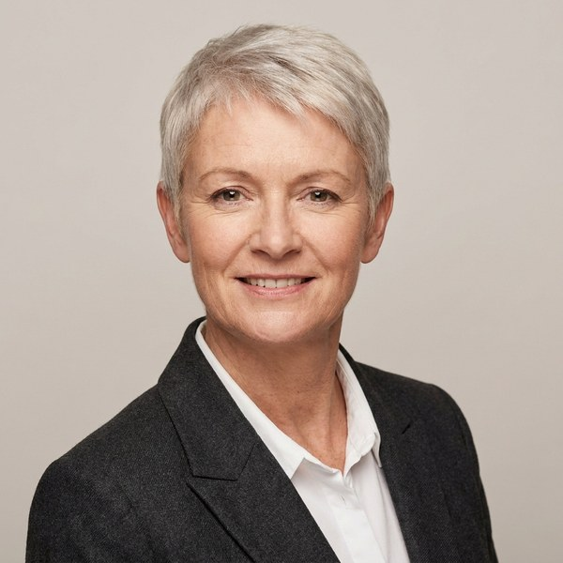 | Curriculum vitae  Alexandra Kerr  Office Manager  Edinburgh
■ Profile
Alexandra has managed offices for small professional firms for six years, covering facilities, suppliers and administration.
■ Key skills
Office management ​ Supplier contracts ​ Microsoft 365
■ Career history
2019 – Present  Edinburgh | Office Manager  Lindsay Harper Architects  – Moved the practice of 25 people to a new office with no lost working days

