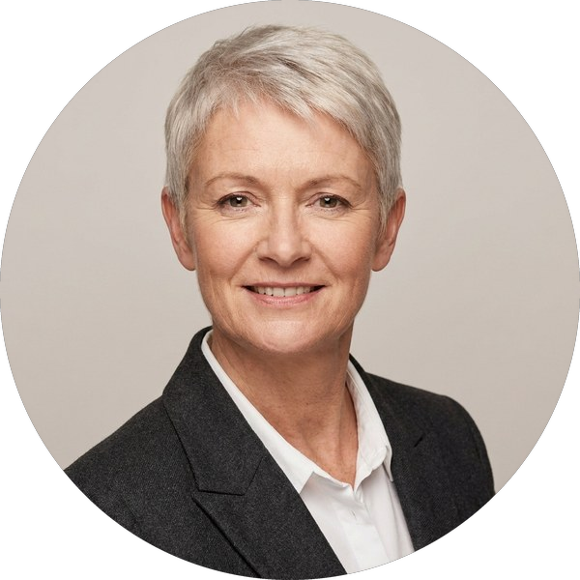 | Candidate for Group Chief Executive · Halden Group  Alexandra Kerr  Chief Executive Officer · Harbourline Distribution · London, UK  Chief Executive who has doubled a £1.1bn distribution business and taken it through a successful sale

Leadership | Largest scale | Board | Availability
17 years in P&L roles | £1.1bn · 6,800 people | plc NED · RemCo Chair | 6 months · will relocate

Profile  Alexandra has led Harbourline Distribution as CEO since 2019, growing revenue from £540m to £1.1bn through organic expansion and three acquisitions, and leading the business through its sale to Brookmere Capital in 2024. Before that she was COO of Stratton Rail Freight and spent a decade in operational and finance leadership at Kestrel Freight. She is known for building strong executive teams, disciplined capital allocation and a calm, direct style with boards and investors.  Career  Chief Executive Officer · Harbourline Distribution 2019 – Present  £1.1bn revenue, 6,800 people; sale to Brookmere Capital (2024) at 11.4x EBITDA  Chief Operating Officer · Stratton Rail Freight 2015 – 2019  Led a £120m network modernisation; EBITDA margin up from 7.9% to 11.2%  Managing Director, UK · Kestrel Freight 2011 – 2015  P&L for a £380m UK business; returned the division to growth in year two  Finance Director, Operations · Kestrel Freight 2005 – 2011  Finance lead for the network redesign and two bolt-on acquisitions  Senior Manager, Transaction Services · Calder & Webb LLP 2001 – 2005  Due diligence on mid-market logistics and industrial deals  Track record  - Doubled revenue to £1.1bn in five years while lifting EBITDA margin from 8.1% to 12.6%  - Led the 2024 sale to Brookmere Capital at 11.4x EBITDA, retaining the full executive team  - Completed and integrated three acquisitions with no loss of key customers  - Built a diverse executive team: four of seven direct reports promoted from within |  | Board and governance  Non-Executive Director  Corran Foods plc · 2021 – Present  Chair of the Remuneration Committee; member of Audit  Board member (executive)  Harbourline Distribution · 2019 – Present  Reports to a private-equity board  Trustee  Freight Skills Foundation · 2018 – Present  Charity funding apprenticeships in logistics  Education  MBA, INSEAD (2010)  ACA, ICAEW (2004)  BSc (Hons) Economics, University of Bristol (2000)  Compensation CONFIDENTIAL  Current base salary £520,000  Annual bonus Up to 100% of base  Long-term incentive PE management equity  Expectation £575,000 – £625,000 base  Notice period 6 months  Figures as stated by the candidate; not for onward disclosure.

Consultant’s view
A proven, investor-ready CEO with a clean record of growth and exit. The move to a listed group is the main change; her plc NED role and audit experience reduce that risk. Recommended for first-round interview with the Chair.
Next steps
References | Interview | Contact
Three taken: former Chair, lead investor and a plc board peer | First round with the Chair, week commencing 5 October 2026 | Priya Raman · priya.raman@example.com · +44 7700 900417

